INCREDIBLE THINGS HAPPEN IN AMERICA…

1°) Fold a $20 bill in half…
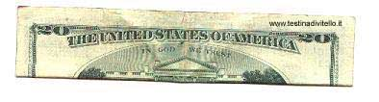

2°) Fold again, taking care to fold it exactly as below
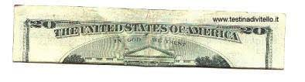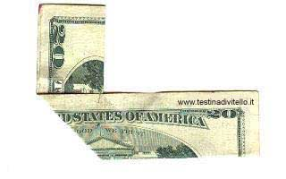

3°) Fold the other end, exactly as before
Et voilà, the PENTAGON on fire!!
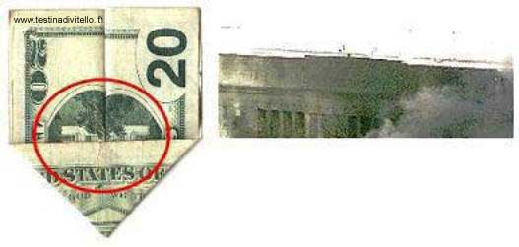
4°) Now, simply turn it over…
The Twin Towers ablaze….
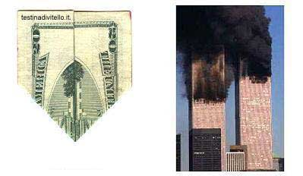
What a coincidience! A simple geometric fold creates a catastrophic premonition printed on all $20 bills!!!
COINCIDENCE? YOU DECIDE

As if that wasn’t enough… here is what you’ve seen…
Firstly The Pentagon on fire…  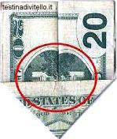 | Then The Twin Towers…  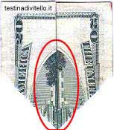

… and now… look at this!
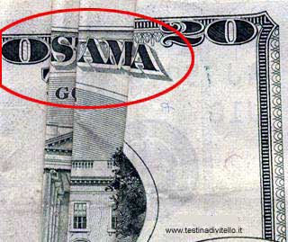
TRIPLE COINCIDENCE ON A SIMPLE $20 BILL

